Telephone: 02 6263 4127
E-mail: guy.thorburn@aga.gov.au

16 October 2023
Mr Kurt Fearnley AO
Chairman
National Disability Insurance Agency
GPO Box 700
CANBERRA ACT 2601

Dear Kurt

JUNE 2023 FINANCIAL SUSTAINABILITY REPORT
I am writing as the Reviewing Actuary of the NDIS to summarise my review of the 30 June 2023 Financial Sustainability Report (FSR), prepared by the Scheme Actuary. Subsection 180E(2) of the National Disability Insurance Scheme (NDIS) Act 2013 (the Act) requires that I review each FSR and report to the Board on my findings. Subsection 180E(4) of the Act requires that I report any significant concerns about the sustainability of the NDIS to the Board as soon as is practical.

Financial Sustainability Report
The FSR presents a ten-year projection of the expected costs of the scheme. The projection has necessarily been developed in two steps. These are defined below, for the purposes of this review.
- The first step uses assumptions that are guided by recent scheme experience, and the Scheme Actuary’s judgement. I refer to this as the Baseline projection. This is what is expected to occur if experience continues along similar lines to that which is currently occurring. This projection uses a comparable approach to the projection set out in the 2022 FSR.
- The Baseline projection is then reduced by a range of initiatives intended to improve the sustainability of the scheme. Some of these initiatives were set out in the May 2023 Budget. This is referred to as the June 2023 projection in this letter.

Review of the Financial Sustainability Report
Subsection 180B(1) of the Act requires the Scheme Actuary to prepare a FSR, at least annually. The FSR provides a projection of the total amount spent by participants and agency expenses for the scheme. Part 3 of the NDIS Rules for the Scheme Actuary sets out the required content of the FSR.
I have been provided with [1] a subset of the Scheme Actuary’s paper to the Sustainability Committee on 15 August, setting out high-level results of the Baseline projection; [2] a draft of the FSR, received on 13 October; [3] Excel models used to derive the Baseline and June 2023 projections; and [4] supplementary information summarising the experience of the scheme to date that enables me to examine the reasonableness of some assumptions underpinning the Baseline projection. I have also discussed some of these materials with members of the Agency’s actuarial team.
The Agency has provided me with the material required to undertake a review of elements of the Baseline projection. I have noted where it has been necessary to limit the scope of this review throughout this letter.
The last FSR I reviewed was the 30 June 2022 FSR. This review focusses on the reasonableness of the 30 June 2023 Baseline projection. Commentary on changes between projections refer to changes since the 30 June 2022 projection.
For this review, commentary on the short-term refers to the four-year Budget period; the medium term refers to the balance of the ten-year projection presented in the FSR; the long term refers to the period beyond the medium term.

The Projection

Methodology
There have been several changes to the projection methodology this year. Three models are used to produce the analysis presented in the FSR.
- An Excel model that generates a projection of scheme outflows over a 10-year period,
- A SAS model that projects scheme outflows beyond 10-years, and
- A model built in R that replicates the Excel model and is used for stochastic modelling.

Excel and SAS Models
These models project scheme costs by multiplying expected participant numbers by the expected average amount spent.
Participants are grouped into 2,052 cohorts and each cohort is projected forward. The cohorts are defined by disability type, functional capacity, supported independent living (SIL) status, age band, and gender. The projected number of participants in each cohort allows for existing participants growing older, future new entrants, participants who leave, and participants who die. The projected composition of the scheme also allows for those with developmental delay to transition into cohorts of participants with autism or to intellectual disability, should that diagnosis occur. It also allows for the transition of participants who do not receive SIL to start to receive SIL. Explicitly incorporating the transition between non-SIL and SIL is a model enhancement for this 2023 FSR. No other transitions are explicitly allowed for, most notably, the transition from one level of functional capacity to another.
The average amount spent is projected for 15 support categories. Average payments are based upon the three months of experience to 30 April 2023 for those who have been in the scheme for more than twelve months. For non-SIL participants, these averages are reduced by 35% in the first year of participation. No reduction factor is applied for those in SIL. The process used to model lower costs for recent entrants has also been updated for the 2023 FSR.
In future years, the average amount spent is increased to allow for the effect of both normal economy-wide wage and price inflation, as well as for the effect of additional scheme specific inflation. As noted above, the models do not explicitly model deterioration in function over time. As a result, this must be accounted for in the additional growth assumption. This both increases the dependency of the results on this additional growth assumption and complicates the analysis associated with understanding the drivers of this additional growth assumption.
The process outlined above is used to derive the Baseline projection. The Excel model has also been enhanced to incorporate specific adjustments to assumptions to allow for the effect of various management initiatives (both those included in the 2023 Budget and further initiatives). When this functionality is used, it adjusts the Baseline projection to result in what, for this letter, I have termed the June 2023 projection.

Baseline projection

Comment on key population assumptions

Starting population
The projected population has been updated to allow for the fact that the starting population at 30 June 2023 is 3.1% higher than expected in the 2022 FSR. The number of participants estimated to be receiving SIL is 12.4% higher than expected in the prior FSR.

New entrants
The number of new entrants in 2022-23 exceeded that which was expected in the 2022 FSR by 22% (15,654 new participants). The 2022 FSR expected that new entrants would reduce by 8,574 participants compared with 2021-22 levels. This did not materialise. By contrast, the number increased by 7,080. Attachment A shows that this was attributable to more new entrants than expected aged below age 14 with autism and developmental delay.
New entrant assumptions in the Baseline projection have been increased over the 2022 FSR to reflect recent experience more closely. This increase was incorporated into the December 2022 projection used to inform the (short term) May Budget. The actual number of new entrants in 2022-23 was marginally lower than that which was assumed in December. The Baseline projection is marginally lower than the December 2022 projection. Figure 1 compares the actual experience with these three projections.
The immediate observation regarding the Baseline projection is the implicit assumption that the number of new entrants will reduce from 2023-24. This reduction is not evident in the most recent experience. There is a risk that new entrant numbers will be higher than assumed, particularly in the medium term.
Figure 1: Actual & projected total number of new entrants.
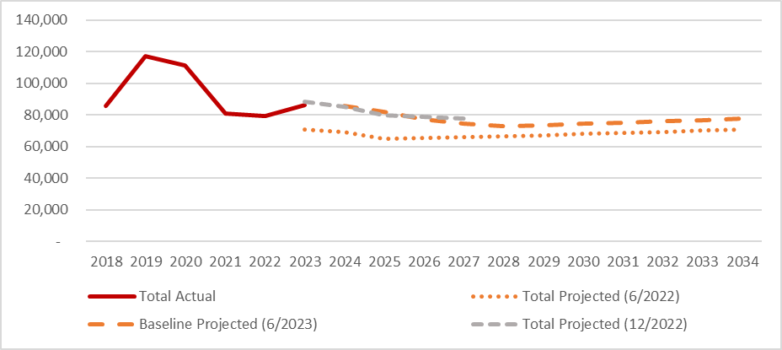
The Baseline projection is higher than the 2022 FSR. Attachment A shows this is attributable to higher numbers of children aged 0-6 expected to enter the scheme, similar levels of children aged 7-14 and lower levels of new entrants aged 15 and above. Despite the increase from the 2022 FSR, there is a risk that the actual number of future new entrants will be higher than expected as:
- Figure 8 shows that the number of children entering the scheme aged 0-6 has increased significantly over the past three years. This increase is assumed to stop and new entrant numbers in this age group are projected to remain flat. This trend is not yet evident in the data.
- Excluding participants with autism and developmental delay, the number of new entrants aged 15-64 was around 8% lower in 2022-23 than expected in the 2022 FSR. The projected number of new entrants in these categories has been reduced by 18% in the 2023-24 projection year, compared with the 2022 FSR. The reduction in the 2033-34 projection year is 22%, compared with the 2022 FSR. Whilst the reduction in new entrants over the last two years has been 18% per annum, how this might moderate is a matter of judgement.
The 2023 Baseline projection includes new entrants with a previously unmet need (PUN). New entrants are considered to have a PUN if (broadly) they have taken longer than 12 months since the last event impacting their functional ability to present to the scheme. The assumptions in the Baseline projection increased the expected number new entrants after June 2023 with a PUN from 4,655 in the 2022 FSR to around 18,000 (noting that this acts to reduce the underlying number of non-PUN new entrants). These future new participants with a PUN are all expected to enter within three years. Disability experience in other Commonwealth schemes shows that an individual’s pathway from a disability to the time of claim can take many years. There is limited evidence supporting the view that there will be no individuals classified as having a PUN joining the scheme after three years. There is a risk that the cohort of participants that take longer than 12 months to present to the scheme will persist beyond three years and that the number of new entrants will then be higher than expected.
The Baseline projection also includes an allowance for additional new entrants arising from changes to migration laws. This further increases the short-term loading for new participants with a PUN by 1,835 new entrants and increases the long-term incidence rate for new entrants by way of a new disability by around 1.2%. I have not reviewed these assumptions.
The uncertainty surrounding new entrant assumptions and their assumed moderation is a key contributing factor to my conclusion that the Baseline projection is more likely to understate, rather than overstate, future costs.

Leaving the scheme
The projection incorporates assumptions regarding the proportion of participants that will leave the scheme to live independently.
Attachment B compares recent and projected experience. Despite the larger number of participants in the scheme, 25% fewer people left in 2022-23 compared to the prior year. The number of exits were 40% below projected. Exits were materially lower than projected in all major categories of disability. The Scheme Actuary’s report to the August Sustainability Committee states that exits reduced due to resource constraints. The Baseline projection assumes resource constraints have been addressed and exits immediately return to the rates assumed previously. The Board should note this assumption and its connection with Agency resource plans.
As noted earlier, the projection does not explicitly model transitions between levels of function. This results in a mismatch between the derivation of assumptions regarding the rate at which participants will leave and the application of the rates in the model. This may result in the model projecting higher numbers of participants leaving than will occur in practice. The variations between forecast and actual exits from this cause is likely to be less than the variations arising from the resource constraints that occurred last year. Nevertheless, I note this technical limitation in the modelling remains. The approach taken has the capacity to also impact the projected number of deaths and SIL transitions. I mention these additional impacts here to avoid repeating the same point later in the letter.

Deaths
The projection incorporates assumptions regarding the proportion of participants that will die.
Attachment B compares recent experience to that which has been projected. The number of deaths in 2022-23 exceeded that which was projected in the June 2022 FSR by over 25%. The June 2021 FSR also underestimated the number of deaths in 2021-22, by 22%. Whilst this occurred in the context of the COVID-19 pandemic and Australia experiencing significant excess deaths in 2022-23, it is appropriate that the Scheme Actuary has reviewed the mortality assumptions in this FSR.
Figure 15 (Attachment B) shows that the 2023 Baseline projection incorporates marginally higher rates of mortality. I regard this as a measured response, in the context of variations in mortality in the wider population. Mortality assumptions may need to be further reviewed depending on whether current elevated level of deaths in the wider population return to pre-COVID levels. Figure 16 shows assumptions are more closely aligned to experience for SIL participants.

SIL population projection
The projection of participants receiving supported independent living (SIL) accounts for around 30% of the total outlays of the scheme, despite accounting for only 5% of participants. Small changes in the SIL population have a material impact on costs.
The June 2023 FSR has enhanced the methodology for projecting the number of SIL participants. This projection explicitly models the transition of non-SIL participants to SIL. Transition rates can reflect the experience of participants by age, level of function and duration in the scheme. The model allows for transition rates to stabilise over five years.
Incorporating explicit SIL transition rates into the projection is a welcome enhancement to the model as it allows a more targeted approach to projecting SIL participants. Transition rates have been set to have regard to the proportion of non-SIL participants in each cohort (defined by disability, level of function and age) that transitioned into SIL over the last 10 months. I regard this approach as reasonable. The transition rates selected generally result in a growing incidence of SIL utilisation at older ages and amongst those with stroke, spinal cord injury and “other” disabilities. This provides a basis, against which, transition rates can be monitored, and assumptions adjusted over time.
The number of SIL participants at 30 June 2023 exceeded that which was expected in the 2022 FSR by over 12%. This necessitates an increase in the forecast SIL population over the 2022 FSR.
The vertical bars in Figure 2 show that the transition rates in the Baseline projection reduce the net intake to SIL below the 2022-23 experience. The assumed reduction is from a net intake of 4,868 in 2022-23 to 4,000 in 2023-24, before further reducing to 1,800 in 2026-27. Whilst this is supported by experience over the last six months, historical experience does not exhibit an obvious trend over the past few years. I agree with the Scheme Actuary’s view that, whilst the projection is a plausible scenario, there remains a high level of uncertainty around the emerging experience. It is possible that actual experience will exceed that which is projected.
Figure 2: Projected SIL population (LHS) and net intake (RHS).
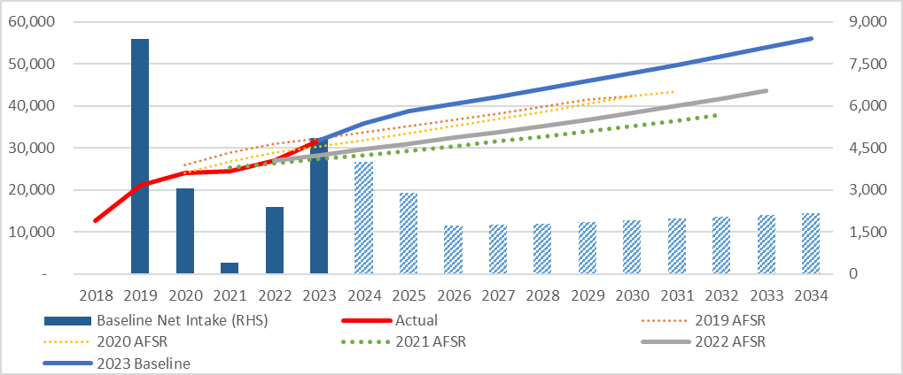
The main cause of exit for SIL participants is death. 644 SIL participants died in 2021-22 and 909 SIL participants died in 2022-23. The Baseline projection assumes 786 deaths will occur in 2023-24. Given the excess deaths in the broader population over the last 18 months, I regard this as reasonable. Given the sensitivity of the projection to the SIL population, closer monitoring of the mortality experience of this cohort is prudent.

Comment on the overall population projection
The projected number of participants in successive FSR projections is set out in Figure 3. The number of participants has consistently exceeded expectations in successive projections. This occurred again this year.
Figure 3: Actual & projected number of participants over time.
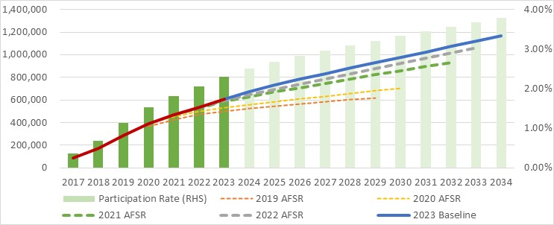
Key areas of uncertainty in the population projection are:
- Assumptions regarding the rate of new entrants, particularly those with a previously unmet need (PUN).
- Assuming the rates at which participants leave will immediately return to the levels expected prior to last year.
- Assuming the net increase in SIL participants will moderate over the next three years.

Baseline Projection: Comment on key participant spend assumptions

Average spend
The 2023-24 expected average participant spend is 6.5% higher in this FSR than the prior FSR.

Inflation
Payments will increase with inflation over time. The projection models inflation in two components. The first component is the effect of normal wage and price inflation on the scheme. The second component represents additional growth that is scheme specific. Total inflation assumptions compound in each successive projection year. As a result, the projection results are increasingly sensitive to the inflation assumptions with each projection year.
The projection models the impact of inflation on each payment type. Assumptions quoted in this letter are averages and are provided to assist the reader understand the trends in the Baseline projection.
The Baseline projection assumes that normal inflation reflects the scheme’s 1 July 2023 price increase and then follows broader economic forecasts. This is set out in Table 1.
Table 1: Comparison of normal inflation assumptions
 | 2023-24 | 2024-25 | 2025-26 | 2026-27 | 2027-28
2022 FSR | 2.6% | 3.6% | 3.6% | 3.2% | 3.3%
2023 Baseline | 4.4% | 3.2% | 3.9% | 3.5% | 3.5%
Change | 1.8% | -0.4% | 0.3% | 0.2% | 0.2%
Numbers may not add due to rounding

Selecting assumptions for additional growth has been challenging in successive FSRs. Figure 4 illustrates past volatility in this component of inflation. This is a source of uncertainty in the projection.
Additional growth in 2023-24 is assumed to be 7% (4% higher than assumed in the 2022 FSR for 2023-24). This is supported by high rates of growth in plan sizes and increasing utilisation. Plan sizes increased by 19.4% in the year to June 2023. The Scheme Actuary has attributed 10.3% of this to factors modelled in other assumptions, leaving 9.1% plan growth that could contribute to additional growth. This remains a highly variable aspect of the scheme experience, however the increase in additional growth in the short term is justified by the fact that participants are using their plans at an increasing rate, and these plans are continuing to increase. The rate of additional growth is expected to moderate from 2023-24.
Figure 4: Observed & projected additional growth.
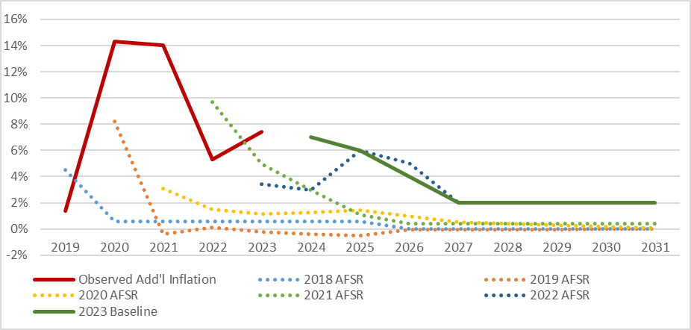
All else being equal, the changes in inflation result in costs being roughly 4.3% higher after three years and then growing at a rate that is 0.2% per annum faster than the 2022 FSR.

SIL
Over three years, the average SIL payment in the 6-months to June of each year increased by 8.8% per annum. Over the last 12 months, this increase was 13.2%.
The Baseline projection assumes the rate of growth in average payments will slow. Average payments are projected to be just under 6% higher than the most recent 6 months in 2023-24, before increasing by just under 10% in 2024-25. Thereafter the rate of increase is assumed to reduce to just under 8% in 2025-26, before slowing to an annual growth rate of between 5% and 6% per annum thereafter. This assumed long-term rate of growth is lower than observed in any of the last five years. There is therefore a risk that this Baseline projection understates the expenditure that may arise.

Budget Initiatives
Last year, new entrants were 22% higher than expected and exits, for reasons other than death, were 40% lower than expected. The number of participants receiving SIL is now 12% higher than expected. These significant variations exacerbated the pressures on the scheme’s financial sustainability that were already present in the 2022 FSR. In the May 2023 Budget, the Government committed $733.9 million over four years for a range of initiatives to improve the sustainability of the scheme.
These initiatives reduce the Baseline projection by $15bn over 2023-27, with lower costs continuing over the 10-year projection (refer June 2023 projection in Figure 5). There is additional uncertainty in the June 2023 projection. Areas of uncertainty include:
- These initiatives are subject to a co-design process that is not yet complete.
- The funding for the initiatives lasts four years, whilst the initiatives are expected to result in lower expenditure in perpetuity. The Board should satisfy itself that the benefits of these projects will endure beyond the funding window.
- As the Baseline forecast is used as a base for assessing potential changes, consideration needs to be given to the moderation of experience already incorporated into the Baseline projection. The Board needs to be confident this moderation will occur before the impact of further actions are assessed.
Given this uncertainty, I concur with the Scheme Actuary’s recommendation to establish a governance structure for implementing, and monitoring the effectiveness of, these initiatives.

Operating Expenses
The projections include an allowance for operational expenses. Table 5.36 of the FSR shows projected operational expenses which are 37% higher than budgeted expenses in 2026-27. To the extent that forecast outcomes are dependent on agency resourcing in the medium term, these differences will need to be reconciled.

Overall results
Figure 5 shows that the resulting Baseline projection (solid blue line) is higher than the projections in all earlier FSRs (represented by the dotted lines). This increase is primarily attributable to the combined effect of:
- The higher initial population projection,
- The initial population having larger plans than previously expected, and
- The total amount spent by that larger population growing at a compounding rate that is higher than previously envisaged.
This is only partially offset in the medium term by the population growing at a slower rate than previously envisaged.
The projected growth in the Baseline projection would result in the scheme being a higher percentage of GDP than presented in all previous FSRs.
Figure 5: Actual & projected total participant spend and agency expenses.
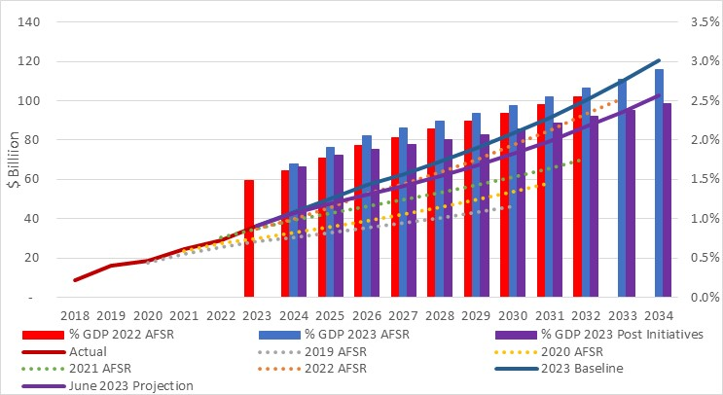
The purple line shows that the trajectory of the scheme is expected to be lower in the medium term, due to a range of initiatives announced in the 2023 Commonwealth Budget. This does not incorporate any further recommendations from the NDIS Review.

Uncertainty
Uncertainty is a feature of any projection. The R-model and sensitivity tests illustrate uncertainty. I have not reviewed the R-model.
Future experience will differ from, and may exceed, that which has been projected. Key areas of risk in the baseline projection include reducing rates of additional growth, new entrants and transitions to SIL, coupled with increased rates of exit. There is further uncertainty in the assumptions relating to budget initiatives. I concur with the Scheme Actuary’s recommendation to ensure appropriate governance is established to monitor the implementation of these initiatives.

Sustainability
Sustainability is defined by the scheme. It is achieved when the scheme is meeting participants’ needs by achieving positive outcomes, and is doing so at a level that is, and is expected to remain, affordable. Participant outcomes and affordability need to complement each other.
The NDIS Quarterly Report to Disability Ministers sets out a range of participant outcomes, including participation in community, employment, and participants’ satisfaction with elements of the scheme. There are mechanisms in place that measure this first component of sustainability. This letter does not review these measures.
It is also necessary to consider whether the scheme is likely to remain affordable, or financially sustainable. The Government defined financial sustainability in the short term in the 2023 Budget. For the medium term, National Cabinet committed to a NDIS Financial Sustainability Framework in April 2023. The Framework provides an annual growth target for NDIS participant expenses of no more than 8 per cent by 1 July 2026, with further moderation of growth as the scheme matures. This letter discusses financial sustainability against this target. I have assumed the rate of growth reduces beyond 2026 by 0.1% per annum (i.e. growth is assumed to be 7.9% in 2027, 7.8% in 2028, etc). Figure 6 compares the Baseline and June 2023 projections with this target.
The Baseline projection exceeds the target. Over the last three years the average spend-per-plan increased by more than 8% per annum for all categories of disability except one. The number of participants also grew by more than 8% per annum. It is therefore not surprising that the Baseline projection exceeds the target in Figure 6. Continuation of recent scheme experience will create sustainability pressures.
The June 2023 projection incorporates an estimate of the impact of a range of initiatives that are expected to moderate the rate of growth in expenditure over time. Figure 6 shows this June 2023 projection is also above the target in the medium term i.e. the Budget initiatives in themselves are not sufficient to reach the growth moderation target. Note that the June 2023 projection does not incorporate any further recommendations that may arise from the NDIS Review that is currently underway.
Figure 6: Comparison of projected costs with target.
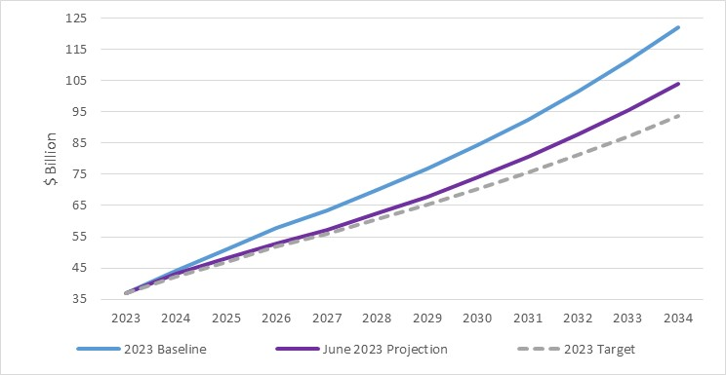
The difference between the Scheme Actuary’s projections and the target illustrates the financial sustainability challenges facing the scheme in the medium term.
In my review of the 2022 FSR I discussed financial sustainability against the benchmark of scheme expenditure being a constant percentage of GDP. As noted in the Intergenerational Report 2023 (IGR), this continues to be a relevant benchmark in the longer term.

Conclusion
The FSR incorporates a Baseline projection, which broadly assumes that emerging scheme experience moderates over time. The Baseline projection is then further reduced to allow for various Budget initiatives.
Recent Financial Sustainability Reports have consistently assumed that scheme experience would moderate in the short term. This moderation has so far failed to materialise, and the projections have been increased each year since 2019 (Figure 5).
The Baseline projection assumes that the number of new entrants, transitions to SIL and additional growth all reduce from recent (higher) levels. It is also assumed that the rate of non-mortality exits will quickly increase. These assumed changes in experience all act to slow the rate of growth in projected scheme costs over time. The Scheme Actuary’s rationale for the moderating experience over time provides support to the view that the Baseline projection is within the range of reasonably likely outcomes. However, I believe that this projection faces a similar risk as all projections since 2019, that is, that the assumed moderation does not materialise. Until the assumed moderating experience shows a greater presence in the data, there remains a risk that the Baseline projection understates what might occur, in the absence of Budget initiatives.
The Baseline projection is then adjusted for a range of initiatives funded in the Budget. I understand that the assumptions underpinning these initiatives were set after discussions between Agency management and the Scheme Actuary. Whilst I have reviewed calculations underpinning the adjustments, I have not reviewed the specific assumptions underpinning the adjustments. Funding for the initiatives was provided in the Budget over the next four years. The initiatives are projected to provide an enduring reduction in scheme experience. The Agency should satisfy itself that these initiatives will create an enduring change, after funding has ceased.
To the extent that these projections are used as a starting point for considering progress against the NDIS Financial Sustainability Framework, care needs to be taken to consider the areas where scheme experience is assumed to moderate. The extent to which assumed moderation does not materialise widens the gap between actual future expenditure and the target.
Yours sincerely

Guy Thorburn
Australian Government Actuary

Attachment A: Distribution of new entrants in the Baseline projection

Distribution by age

Actual and expected experience.
The number of new entrants in 2022-23 exceeded that which was expected by almost 16,000 participants. Figure 7 shows that most of these additional new participants were under the age of 14.
Figure 7: Actual and expected new entrants by age.
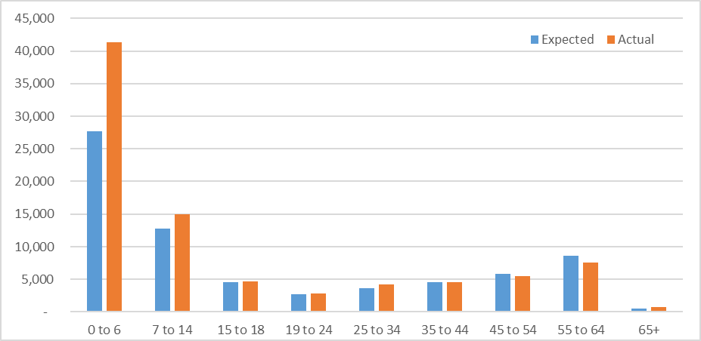
Figure 8 sets out the trends in actual and projected numbers of new entrants by age, for this projection and as projected in the prior FSR.
New entrant projections are framed by the hypothesis that there is a small number of people in the wider community with a previously unmet need (PUN). Broadly, a new participant is considered to have a PUN if they have not approached the scheme within 12-months of a recent event that contributes to their eligibility. In other words, this group are slower to approach the scheme after a change in circumstances than others. It is assumed that all people in this category will join over the next three years.
After three years, new entrant numbers will be lower, reflecting the incidence rate currently observed of people who are joining the scheme within 12 months of the most recent event contributing to their eligibility.
In reviewing the model, it is important to consider how both the assumptions adopted and the underlying hypothesis is supported.
Figure 8: Actual and projected new entrants by age.
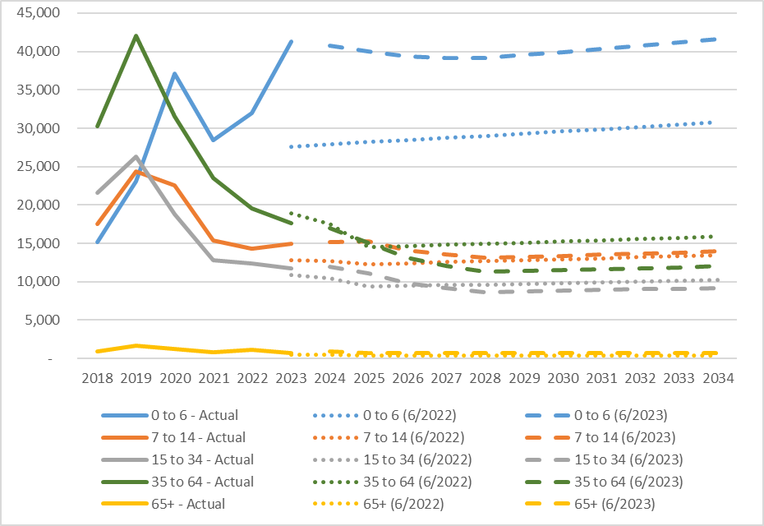

New entrants, age 0-6.
New entrants aged 0-6 have grown substantially over the last three years and were significantly above that which was expected in last year’s FSR (50%). The projected number of new entrants aged 0-6 has been increased from the numbers included in the previous FSR. However, no further growth is assumed. This has been attributed to improvements in early childhood intervention. Nevertheless, as new entrant numbers aged 0-6 are yet to stabilise, there is a risk that this projection will understate the actual numbers of future new entrants aged 0-6.
It is recommended the Scheme Actuary consider if further data could be obtained to better inform the expected maturity of incidence rates at young ages.

New entrants, age 7-14.
The numbers of new entrants age 7-14 have been relatively stable over the last three years at around 15,000 per year. New entrants in this age group are assumed to continue at a similar level to 2022-23 for the next two years, before tapering towards a lower longer term new incidence rate. For this age group, long term new incidence rates are similar to those used in the 2022 FSR.
The Baseline projection assumes around 17% of new participants in this aged group will have a PUN in 2023-24. This cohort of PUN new entrants is now assumed to taper to nil after three years. This is an increase on the 2022 FSR, which assumed no further new entrants from this cohort from 2023-24 onwards. The hypothesis that this group will reduce to zero after three years is a matter of judgement. As this reduction is based solely on judgement, there is a risk this projection will understate the actual numbers of future new entrants in this age group.

New entrants, age 15-64.
New entrants aged 15-64 have been adjusted in the short term to reflect recent higher experience, whilst tapering to lower longer term incidence rates after three years.
Lower long term new incidence rates reduce the number of new entrants by around 5,000 per annum compared with the previous FSR and act to lower the Baseline projection in the medium term.
The Scheme Actuary bases this reduction on the observation that (excluding participants with autism and developmental delay) the number of new entrants aged 15-64 reduced by around 18% per annum in each of the last two years. This reduction largely occurred amongst participants with psychosocial disabilities.
The projected number of new entrants in these categories was reduced by 18% for the 2023-24 projection year. The reduction for the 2033-34 projection year was 22%. This has been spread across all disabilities (excluding autism and delay). Whilst there has been a material reduction in the number of new entrants over the last two years, the degree to which this will continue and how this might moderate is a matter of judgement. Further, reducing the projected number of new entrants across all disabilities, when the most significant reduction occurred in psychosocial disability, risks understating new entrants in some disabilities.
This year, the Scheme Actuary has also formed a view that the current new entrant numbers at these ages include a significantly higher proportion of individuals with a PUN. The assumption is then made that the number of participants with a PUN in the population is finite and such new entrants will reduce to nil after three years. The model provides for 19,915 new entrants with a PUN over the next three years.
There is a significant level of judgement behind the hypothesis that there will be no new entrants with a PUN after three years. I have not received any analysis to support this assumption. Defence Superannuation schemes have a similar cohort of claimants. The analogous cohort in these schemes submit retrospective invalidity claims. The past decade has seen the number of such claims increase steadily, with some claims being made many decades after the incidence of the disability. Previous assumptions that the numbers would reduce in the short term have consistently proven to be wrong. If there can be significant delays between a disability occurring and the date a person presents to the scheme, then it is possible the new entrants, currently considered as PUN, will persist beyond three years.
It is recommended that the Scheme Actuary consider whether analysis of delay patterns is possible to help inform new entrant rates over time.

Distribution by disability
Figure 9 shows the disability types experiencing the highest numbers of new entrants are autism and developmental delay, followed by intellectual disability, and psychosocial disability. Most of the higher-than-expected new entrants were participants with autism or developmental delay.
Figure 9: Actual and expected new entrants by disability.
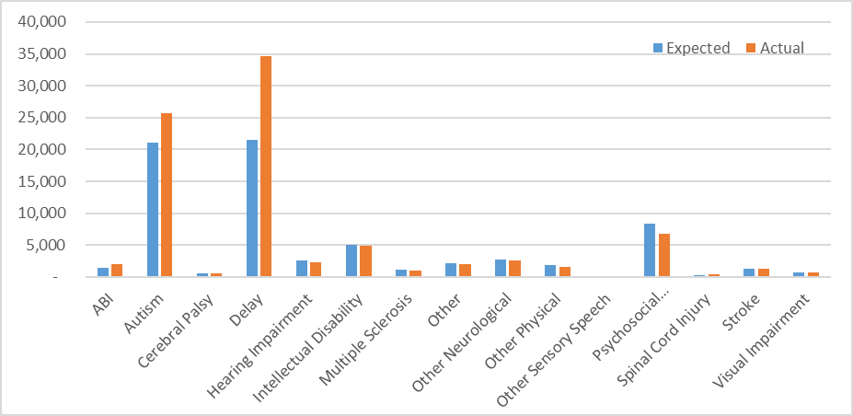
Figure 10 sets out the trends in actual and projected numbers of new entrants by disability, for this projection and as projected in the prior FSR.
Higher numbers of new participants with autism and developmental delay presented to the scheme than were expected in the prior FSR. Consequently, the projected number of new entrants have been increased for these categories. There is a high level of uncertainty in establishing a long-term new entrant rate for these groups as numbers have persistently exceeded expectations and both categories have seen increasing new entrants in recent years.
The cohort of participants with acquired brain injury also experienced a higher number of new entrants than expected. Although the numbers are more modest than the disabilities listed above, assumptions have been increased for this category since the 2022 FSR to allow for (roughly) an additional 500 new entrants per annum in 2023-24, reducing to (roughly) an additional 190 per annum in the medium term.
Figure 10 shows that the number of new entrants with psychosocial disabilities may be tapering faster than expected. The number of new entrants expected in the next two years has been reduced accordingly.
Figure 10 illustrates that the number of new entrants appears to be tapering towards a long-term new entrant rate that is similar to what was expected for most other disability types. Despite this, the expected long term incidence rate for these disabilities has been reduced. This appears to be an outworking of the analysis of new entrants aged 15-64 that resulted in a reduction in new incidence rates applied to all disabilities (other than autism and delay) in the 2023 Baseline projection.
Figure 10: Actual and projected number of new entrants for major disability types.
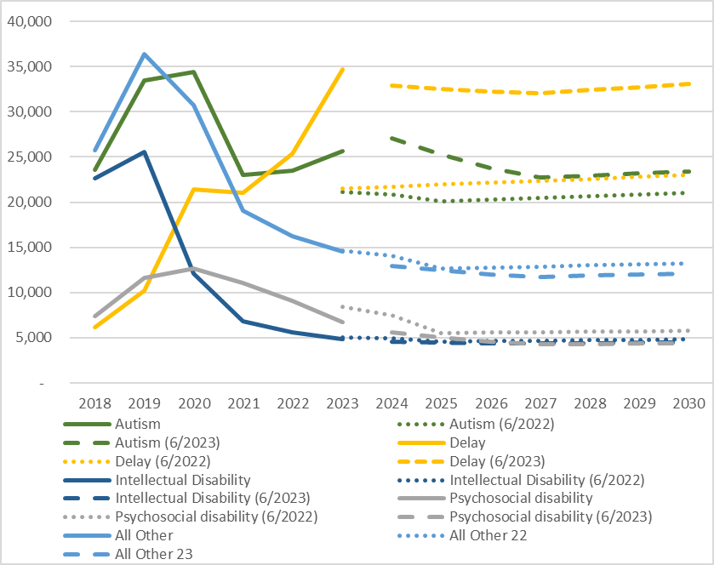

Attachment B: Mode of departure

Leaving the scheme
In 2022-23, 4,994 participants left the scheme for reasons other than mortality, around 3,200 (39%) fewer than projected. This occurred across all disability types. 26% fewer people left in 2022-23 compared to the prior year, despite the larger participant population.
Figure 11: Actual and expected number of exits.
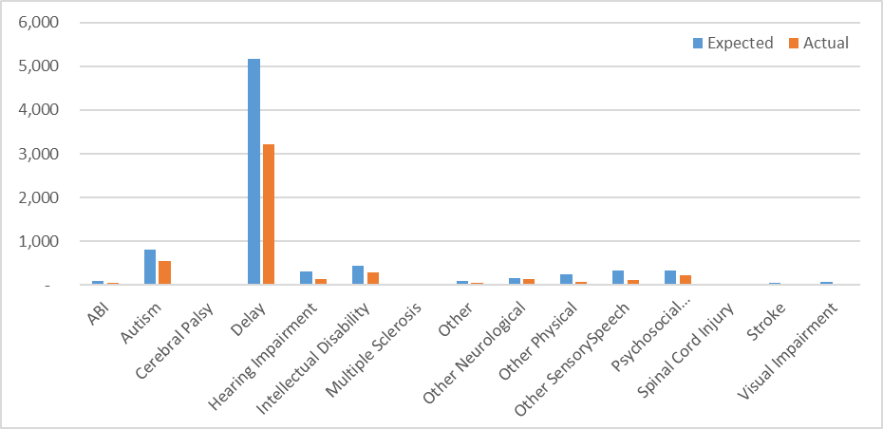
The difference between actual and expected non-mortality exits was greatest for participants with developmental delay. As this is a large category of participants, exit experience of this group drives the overall exit rate of the scheme. Figure 12 compares recent rates of leaving the scheme with recent projections. The overall rate of leaving was expected to stabilise at around 1.5% in 2022-23, instead it reduced to 0.9%.
Figure 12: Actual and projected crude rate of leaving (for reasons other than death).
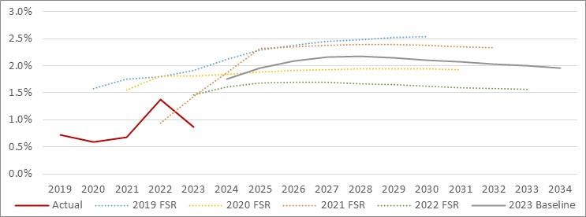
The movement in the rates participants are expected to leave the scheme, for the four largest categories of disability and overall, is illustrated in Figure 13 (all disabilities and developmental delay) and Figure 14 (intellectual disability, autism, psychosocial disability). The four disabilities shown illustrate the exit rates for around 75% of the schemes participants. Two charts are shown due to the different scale for the rates of exit.
Figure 13: Actual and projected rates of leaving by disability – Total & Developmental Delay.
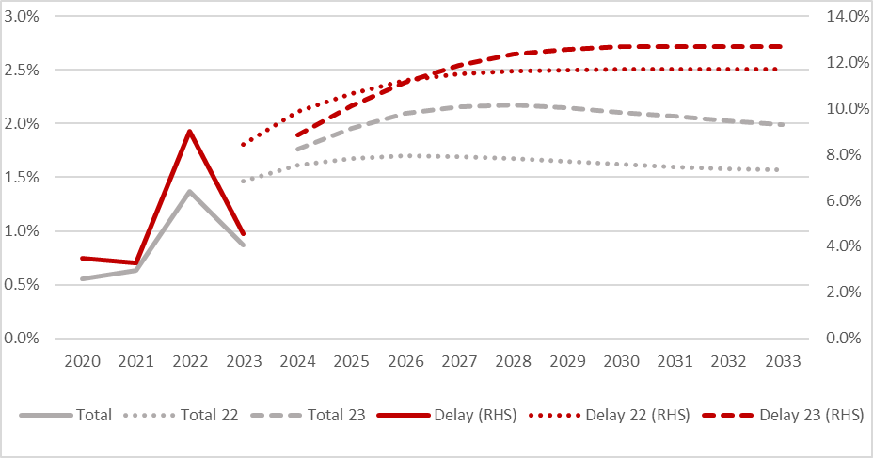
Figure 14: Actual and projected rates of leaving by disability – Autism, Intellectual and Psychosocial Disability.
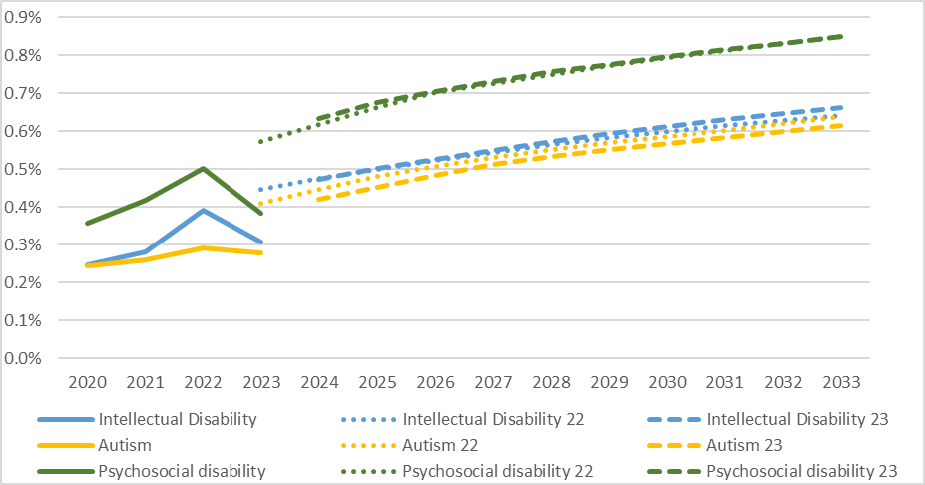
Key observations are:
- The overall average exit rate is correlated to the exit rate for developmental delay as this group generates around 60% of all exits.
- Exit rates for all categories of disability were materially lower than that which was expected in the 2022 FSR.
The Board Paper of 15 August notes that 2022-23 exits were lower than expected due to resource constraints. This FSR assumes those resource constraints have been addressed and exits immediately return to the rates assumed previously. The Board should note this assumption and its connection with agency resource plans.

Mortality
Participants may also cease to participate in the scheme due to their death. In 2022-23 there were 6,123 deaths. This was 1,246 (26%) higher than expected.
Figure 15 compares the recent crude mortality rate for the scheme to recent projections. Historical experience will exhibit significant volatility in a population of this size. The variation in the actual mortality rates from year-to-year illustrates the challenges in setting these assumptions. This challenge is further compounded by the fact that Australia has experienced higher than average levels of mortality over the past year, largely attributable to COVID and the indirect impacts of the pandemic.
Figure 15: Actual and projected crude mortality exit rate.
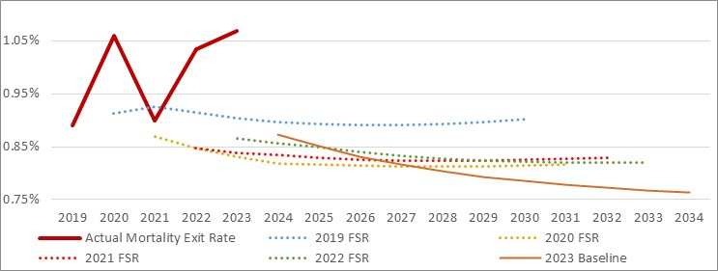
Mortality assumptions have been reviewed for this projection, based on five years of scheme experience to February 2023. This addresses a recommendation made in my review letter dated September 2022. Overall, the expected mortality rates at individual ages have been increased for this FSR, relative to the prior FSR. The crude mortality rate shown in Figure 15 reduces over time, reflecting the higher number of younger new entrants to the scheme (that have lower mortality rates). The projected rate for 2023-24 remains below last years’ experience, and assumes the excess mortality experienced in 2022-23 will subside.
The Department of Health reports the number of deaths from COVID and deaths with COVID amongst NDIS recipients. This identified 439 deaths related to COVID between March 2020 and July 2023. Whilst some care must be taken with this report as the data will not be mature, this might suggest that less than 5% of scheme deaths are related to COVID. The difference between the actual crude mortality rate and the projected crude mortality rate may not be fully explained by excess COVID deaths. This suggests that mortality should continue to be closely monitored.
Mortality assumptions are set by age, disability type, level of function and SIL status. The aggregate result illustrated in Figure 15 masks variations within individual cohorts. Whilst the total number of deaths in the scheme is relatively small, the distribution of deaths can be important. For example, very few participants receiving SIL leave for reasons other than mortality. As a result, the assumed mortality experience of participants receiving SIL has a material impact on SIL projected costs.
Figure 16: Actual and projected crude mortality rate for SIL participants.
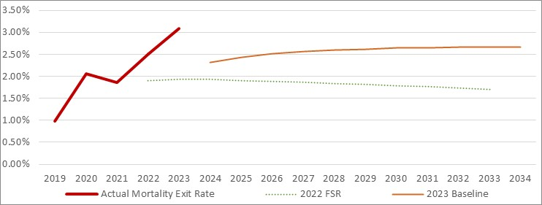
Figure 16 shows that the expected mortality rates for SIL are more closely aligned to recent experience.

Weekly COVID-19 repo...~https://www.health.gov.au/health-alerts/covid-19/weekly-reporting#covid19-deaths-among-people-on-ndis-and-disability-support-pension

